**This Week at WLE – June 8**

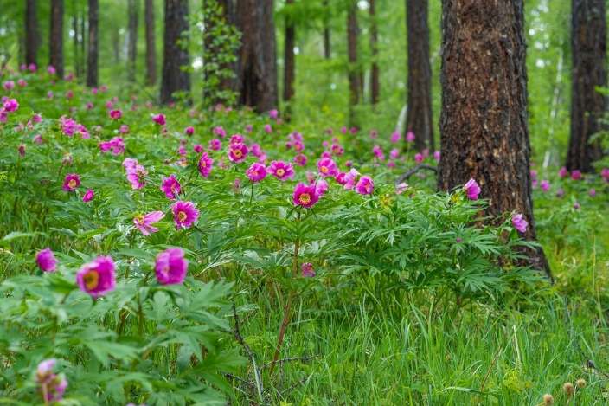

**Superintendent’s Message**

Please see the latest COVID-19 Information Bulletin from Gordon Stewart, Superintendent of Langley School District attached with this notice. This week’s message includes important information about the last week of school and term three report cards.

**General Information**

Monday through Friday, we have students at school who will be accessing the playgrounds and fields. While we LOVE to see everyone, please assist us with maintaining our June 1 School Restart protocols and reserve playing on school grounds or on the playgrounds until after 2:30pm. Thank you for your help.

**Welcome to Kindergarten**

Thank you to the families that were able to join us this week for a brief meet and greet. It was great to see so many of you. If you were unable to join us or have not yet registered for Kindergarten, please contact the school office at 604-888-6444.

**Grade 7 Year End Activities**

Even with schools having a partial re-opening effective June 1, it is disappointing for students, families and staff that we will not be able to celebrate our Grade 7 students with typical West Langley traditional celebrations and events. As outlined in a previous letter from our superintendent, camps and large gatherings can not go ahead which includes our trips to Camp Jubilee and the Cultus Lake Water Slides as well as our Grade 7 large group, in-person celebrations. Staff are having conversations about how to facilitate the tradition of painting ceiling tiles and how to have an alternate, yet hopefully meaningful digital Grade 7 Leaving Ceremony with families participating from their homes. Please “save the date” for Wednesday, June 24 which has been set aside for Grade 7 Leaving activities. More information will be coming in the next few days outlining all of the arrangements.

In the meantime, please make sure you send your photos to Mr. Burwell ASAP to be included in the presentation. Photos can be emailed to [jhimburwell@gmail.com](mailto:jhimburwell@gmail.com). If he has contacted you to arrange times for getting a photo taken, please be sure to reach out to him!

**Family and Community Support Webpage**

District and school staff are continuing to provide support for our families during this challenging time. The District website has a new Family & Community Support page to help parents/guardians cope with the impacts of COVID-19. This page includes links to resources including a comprehensive guide developed by the Langley Children Committee, containing health, housing, and financial support information. On this page you will also find a new weekly blog launched by Gail Markin, who is our District Teacher for Social Emotional Learning. She will be covering a new health and wellness topic every time. Thank you to our community partners for their ongoing support. Visit this page:

<https://www.sd35.bc.ca/news-events/district-board-news/ministry-updates-on-novel-coronavirus-covid-19/community-family-support/>

****Student Corner**

This week’s joke of the week is brought to you by Danica!

***Q:*** *What do you call a bear with no teeth?*

***A:*** *A gummy bear!*

Do you have a favourite joke? Send it to Ms. Potter-Smith and maybe it will be our joke of the week!