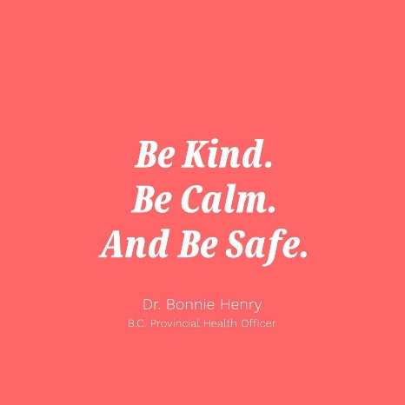**This Week at WLE – April 14**

**Superintendent’s Message**

Please see the attached letter from Gordon Stewart, Superintendent of Langley School District.

**General Information**

This week teachers have been learning about electronic platforms to deliver curriculum, collaborating and developing activities. Some families will have already received digital information on how to sign up for platforms such as EPIC, Mathletics, Microsoft Teams and more. We are working on limiting the various platforms school wide but please note that all classrooms will not be using the exact same programs especially for families who have children in both intermediate and primary grades.

As we embark on the journey of learning at home using online platforms, please be mindful of the chats and discussions students may be having online to ensure they are respectful and appropriate for the learning environment.

As a reminder, the District has created a tech support line for parents to use if their child is having difficulty with accessing their teacher’s technology platform with their device.  To access this support please email the following address  [supportme@sd35.bc.ca](mailto:supportme@sd35.bc.ca) or call 778-726-4508 Monday-Friday between 8:30am and 4pm.

**Access to supplies and student belongings**



For health and safety reasons, we will continue to limit access to the school.  Our Chief Public Health Officer of Canada, Dr. Theresa Tam and the BC Provincial Health Officer, Dr. Bonnie Henry, have both stated that the next few weeks are critical in flattening the curve of the spread of COVID 19.  If you have a critical need, such as needing medication, please call the school to set-up an appointment between 8:30 am and 3:30 pm Monday to Friday (I know Ms. Swerdan misses everyone!).

Parents can now go to School Appointments Online to book a time to pick up your child/children’s belongings which will take place on Thursday, April 16 and Friday, April 17. Please go to <https://wle.schoolappointments.com/admin> to book a time. If these times do not work for your due to work schedules, please contact the school office to make alternate arrangements.

We will be setting up a process that respects all directives of the Public Health Officer and follows Work Safe BC protocols. More details about the process will be sent home in a separate email on Tuesday.

**West Langley Lions Learning Together**

We may not be together in one building, but we are a community learning together apart for now! Please consider sending Ms. Potter-Smith pictures of you and your family learning and playing together that you are willing to have us share on Instagram/twitter. We will share them out weekly as another way of staying connected as a learning community. (This is meant to be a low pressure fun activity!) Photos can be sent to [clambiepottersmith@sd35.bc.ca](mailto:clambiepottersmith@sd35.bc.ca)

**Student Corner**

Every Friday with our morning announcements, we have had a little bit of fun with a joke to end our school week. In keeping with the spirit of routine, here is your joke of the week students! (we can hear the fabulous collective WLE student groan now…)

PS…don’t forget your Secret Mission! (check emails everyone!)

And remember what Dr. Bonnie Henry said:





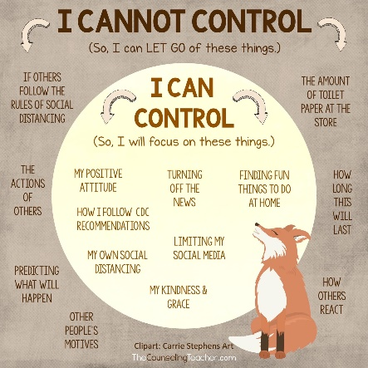**Parent Resources**

1. Telus is starting a new program to provide free Internet to Families who need it as well as refurbished devices to families who need them for continuity of learning: [https://www.telus.com/en/about/company-overview/community-investment/how-we-give/cause-campaigns/internet-for-good](https://can01.safelinks.protection.outlook.com/?url=https%3A%2F%2Fwww.telus.com%2Fen%2Fabout%2Fcompany-overview%2Fcommunity-investment%2Fhow-we-give%2Fcause-campaigns%2Finternet-for-good&data=02%7C01%7Cclambiepottersmith%40sd35.bc.ca%7C7f9763de0a42443c27b708d7d826a897%7Cfcabfaaef80a4f74b6a7ba15c2a4bb24%7C0%7C0%7C637215532871452878&sdata=pRiyyUqnCt5GUQDLzi9APaljEAVcmcBxhaTJSZFX8N4%3D&reserved=0)

1. The Ministry has put together a parent website with resources for them to support learning. This will be a fantastic resource to share with parents for those that want to get going in Week 1 and 2 without teacher guidance. We will put a link to this on our own website but here it is!  [https://www.openschool.bc.ca/keeplearning/](https://can01.safelinks.protection.outlook.com/?url=https%3A%2F%2Fwww.openschool.bc.ca%2Fkeeplearning%2F&data=02%7C01%7Cclambiepottersmith%40sd35.bc.ca%7C7f9763de0a42443c27b708d7d826a897%7Cfcabfaaef80a4f74b6a7ba15c2a4bb24%7C0%7C0%7C637215532871982577&sdata=JrOpBh4iFfzzRrYn%2FCReaQX1JYatAGU6BK613c6vtTU%3D&reserved=0)

Some Considerations for parents and guardians as you support learning at home:

